**CHAPTER ONE**

**INTRODUCTION**

**1.1 Introduction**

Now a day, we live in a hectic world made our interest in maintaining our good health is important. It’s easy makes stress takes center stage and set us up for poor diet and negative lifestyle. The exercises and behavioral choices can have a significant effect on our health. If you have a poor or unhealthy diet, you may run the risk of weight gain or increased your risk of chronic diseases like diabetes or high blood pressure.

If you're not active regularly, you may also run the risk of gaining weight but also miss out on the many benefits of exercise. If you smoke, don't manage stress or don't sleep well, you again can run the risk of having negative side effects on your health. Maintaining a generally healthy body will require you to make sure you're making healthy choices in multiple areas of your life.

**1.1.1 Health**

Health, as defined by the World Health Organization (WHO), is "a state of complete physical, mental and social well-being and not merely the absence of disease or infirmity, also Health may be defined as the ability to adapt and manage physical, mental and social challenges throughout life [11].

Maintaining a healthy body with exercises, include cardio or aerobic exercises are a very important part of a healthy lifestyle and a generally healthy body. There is a huge amount of health benefits associated with regular exercise. from these benefits improved mood, improved sleep quality, improves circulation, helps manage a healthy weight, decreases blood pressure and risk for stroke, manages and controls insulin, improves blood lipid and cholesterol levels, boosts energy and can help improve your self-image.

Health experts recommend getting at least 150 minutes of cardio activity each week or 30 minutes for five times a week. You can increase benefits by getting 300 minutes of aerobic activity each week or one hour for five times a week. try Include a variety of activities each week. such as walking, running, dancing, swimming or aerobics classes. Strength training helps build and support lean muscle mass in addition to providing other health benefits. Strength training and adding muscle can even increase your metabolism and help you lose weight [11].

Regular strength training has many benefits outside of building stronger muscles. Regular weight-bearing exercise helps decrease your risk of osteoporosis by making your bones stronger and denser. Experts recommend doing about two days of strength training each week. It's important to work every major muscle group including arms, chest, back, core, and legs. Lift free weights, use weight machines or do weight-bearing activities like yoga.

Separate each strength training day by at least one day of rest to all your muscles to recover and repair efficiently. Move more throughout the day. In addition to both strength training and planned cardiovascular exercise, it's also important to just move more throughout the day or include more baseline activity. Although these types of activities aren't huge calorie burners, they also have a significant amount of positive health side effects.

Baseline activities refer to any exercise or activity that you do on a regular basis. This could be yard work or household chores, taking the stairs or walking throughout the day [11].

**1.1.2 Health Club**

A health club, also known as a fitness club, fitness center, health spa, and commonly referred to as a gym is a place that houses exercise equipment for the purpose of physical exercise. Every health club provides several facilities and services such as main workout area, which primarily consists of free weights including dumbbells and barbells and the stands and benches used with these items and exercise machines, which use gears, cables, and other mechanisms to guide the user's exercise. This area often includes mirrors so that exercisers can monitor and maintain correct posture during their workout [10].

The second facility A cardio area includes many types of cardiovascular training-related equipment such as rowing machines, stationary exercise bikes, elliptical trainers and treadmills. These areas often include a number of audio-visual displays, often TVs (either integrated into the equipment or placed on walls around the area itself) in order to keep exercisers entertained during long cardio workout sessions. also, group exercise classes, sports facilities, restaurants, child-care facilities, cafes, sauna, steam room, swimming pool and alternative medicine wellness facilities, figure 1.1 Health Club (gym) [10].

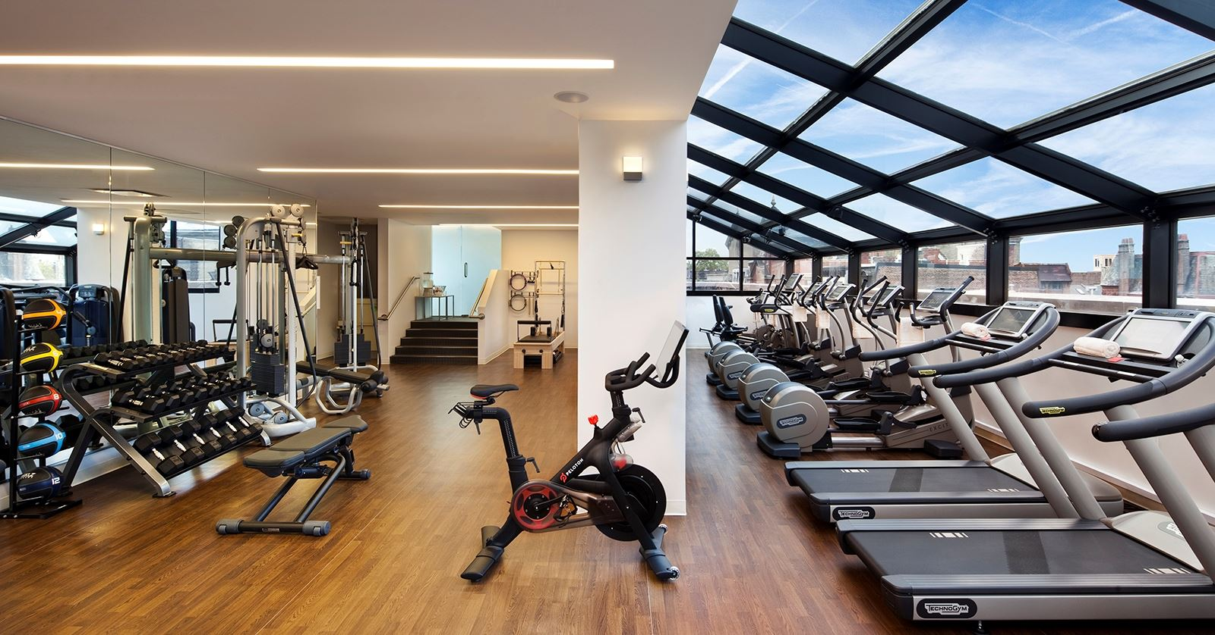

Figure 1.1 Health Club (gym)

**1.1.3 Android**

Android operating system (OS) is widely used by smart phones and tablets. It was originally developed by company with same name (Android) in 2005, as part of Google strategy to enter the mobiles domain, now also used in TVs. It's purchased Android and took over its development work (as well as its development team) [1].

Google intend to make Android to be free, hence, most of Android ‘codes were released under the open-source Apache License, which means that anyone who wants to use Android can do so by downloading the full Android source code [1].

Moreover, vendors (typically hardware manufacturers eq. Samsung, Huawei) can add their own proprietary extensions to Android and customize Android to differentiate their products from others. This simple development model makes Android very attractive and has thus piqued the interest of many vendors. This has been especially true for companies affected by the phenomenon of Apple’s iPhone, a hugely successful product that revolutionized the Smartphone industry [1].

Android has taken the world by storm, everybody wants a Smartphone or tablet, and Android devices became hugely popular. Android powers hundreds of millions of mobile devices in more than 190 countries around the world. It's the largest installed base of any mobile platform and growing fast. Every day more than 1 million new Android devices are activated worldwide [2].

User interaction with an android device is primarily visual and tactile in nature. All these interactions took a place through the user interface of the applications that are installed on devices. Including both the built-in applications and any third-party application installed by the user. The spread of variety of Android applications.

The version history of the Android mobile operating system began with the release of Android alpha in November 5. 2007. The first commercial version, Android 1.0, was released in September 2008. Android is continually developed by Google and the Open Handset Alliance, and it has seen a number of updates to its base operating system since the initial release.

Versions 1.0 and 1.1 were not released under specific code names, but since 2009's Android 1.5 Cupcake, Android versions have had confectionery-themed code names. Each is in alphabetical order, with the most recent major version being Android 8.0 Oreo, released to the public on August 21, 2017 [2].

**1.2 Background**

There are several projects in this area but don't focus on enhancing and manage the relationships between the coaches and trainees, each project has pros and cons points, chapter two will review details each project for show services, points of strength and weakness.

**1.3 Problem Statement**

Trainees face several issues while training, which lead to lost time, changes of the weight, from the coach side, don't focus on training and in manage the relationships with trainees and following them.

**1.4 Scope**

This App for trainee in gym as a tool to help in managing training and every coach he supervises several trainees.

**1.5 Objective and Goals**

Enhance the relation between the coaches and trainees to ensure best results.

also, we seek to achieve these goals: -

* Save time in communication.
* Monitor the progress of the trainee.
* Enable the coach to perform online tasks.
* Enable trainee to switch from coach to coach or gym to gym.

**1.6 Project Motivation**

The main cause of the work of this project to help in resolve a lot of health problem because the people suffering of chronic diseases or issue in weight is increasing in every day.

Pushing people and encourage them to go to the gym by providing easier means to help them during training.

In this project, we will learn several technologies for implementation project with huge experience. In the end road, we will have experience in Android development, NoSQL Database (Firebase) and Google API.

**1.7 Contribution**

The main contribution is built new application help in management relations between coaches and trainees in health clubs (gym) easier than before and help the coaches to solve a problem can't management several trainees at the same time because it, lead to getting a personal trainer involves an additional fee.

Also, instead of having a trainee thinking a lot about what will do in training or how you will implement them will enough the use the application to avoid all that. Moreover, you can save time by using this program and invest it in other productive process within your life.

**1.8 Organization of the chapter**

**Chapter.1 Introductions**

**Chapter.2 related works**

This chapter will present the theoretical background of the project and some of the similar works presented currently, advantage, disadvantage and some comparison.

**Chapter.3 system analysis**

In this chapter, a detailed analysis of the systems, project mythology and talk about system planning and requirements of it you find it in.

**Chapter.4 system design and implementation**

This chapter contains how the proposed system is implemented and the methods used to that.

**Chapter.5 results and discussion**

This chapter will discuss the results obtained from the proposed and implemented system. And what we have realized in this project.

**Chapter.6 conclusions and future works.**

**CHAPTER TWO**

**BACKGROUND AND RELATED WORKS**

**2.1 Introduction**

Many of Trainees face several issues while training, which lead to lost their time, which will lead to lack of focus, after a while the trainee will get bored and desperate to reach the goal he wants.

The training should proceed from the philosophy of non-learning without learning, both of which should be a source of fun for trainers and participants at the same time. Learning experiences such as listening, participation, negotiation and reflection should be linked to training with co-trainer and participant learning strategies. Learning at the same time for both trainers and participants.

From here we begin to understand the role of the trainer in training that lies in the management of the course. From here, we wanted to allow the trainer to run the course through technology.

**2.2 Theoretical background**

In our normal life we ​​go to the gym and do the exercises prescribed by the coach without any interaction, why there is no interaction with the coach during the training through technology.

**2.3 Related Application**

In searching about new ideas for our project, found related works to our project, here are some gym apps, some websites, some apps, some both: -

**2.3.1 The Training Note Book** [3]

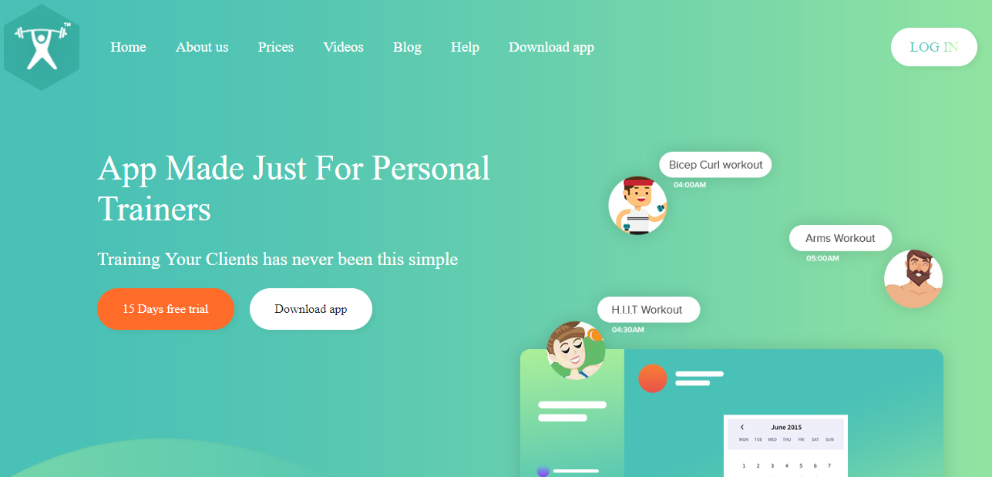

Figure 2.1 The Training Note Book

[The Training Notebook](http://www.thetrainingnotebook.com/) is one of the most robust and simple iPad apps out there for personal trainers. The home page gives you a central hub where you can easily access each one of your client’s workout regimens, training schedule, contact information, and assessments.

The program page allows you to start building your client’s training program in just minutes. You can then copy and paste your favorite workouts, email them to your clients, and you can even choose from pre-made program templates.

It doesn’t stop there; the body assessment feature allows you to store before and after pictures of clients in one place. Additionally, you can input caliper readings into the app and it will calculate the rest for you [3].

**2.3.2** **Coach Pro** [4]

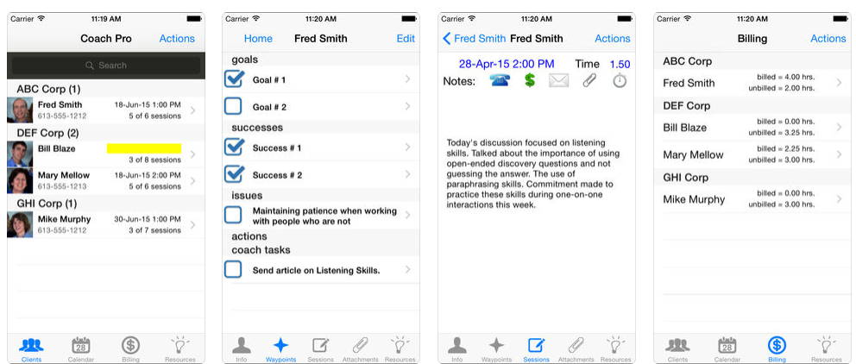

Figure 2.2 Coach Pro

Coach Pro is an app designed by trainers to help you scale your personal training business. The app comes with over 1,600+ exercises in their database and is developed to help you draw in a larger tech-savvy client base. with Coach Pro trainer, you can communicate with your clients, create programs and train clients remotely.

The ease-of-use will help you retain clients longer with more consistent training. The developers thrive on using the latest technologies and simple, effective design methods so you can focus more time on growing your client base and less on unnecessary client instruction.

**2.3.3** **FitSW** [5]

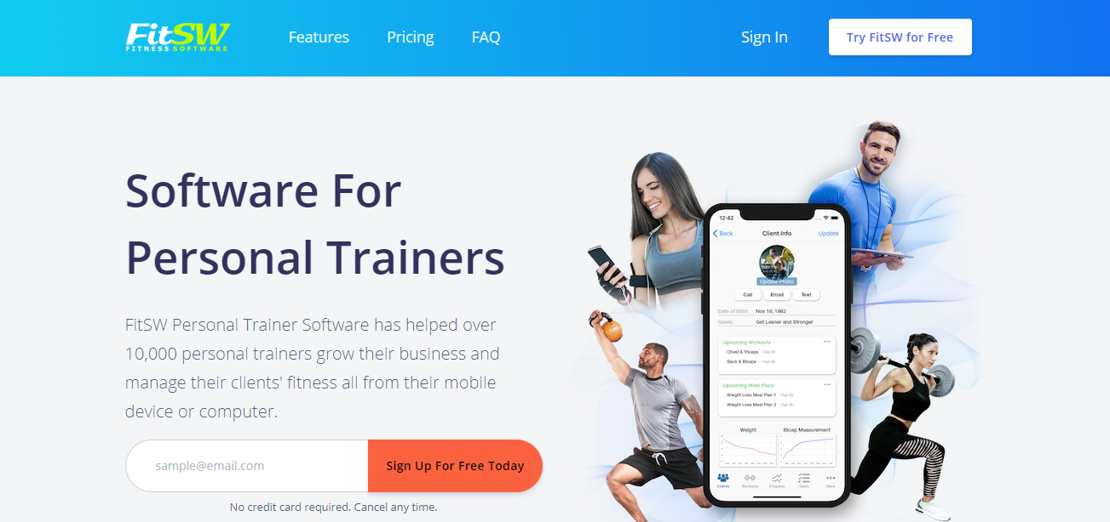

Figure 2.3 FitSW

[FitSW](https://www.fitsw.com/) is an excellent app for staying in communication with your clients. It allows you to manage multiple clients, their workouts, fitness progress graphs, and more all in one centralized location.

This makes it easier for you to stay on the same page with your client. Goal progress tracking and fitness graphs helps your clients stay motivated which will help with client retention.

It also includes a large workout database with demonstration videos so your clients know exactly how to perform each exercise you assign them.

Table 1.1. Shows the Comparison between related works.

Table 2.1: Comparison Between Related Works

|  |  |  |  |  |
| --- | --- | --- | --- | --- |
| # | The Training Note Book | Coach Pro | FitSW |  |
| Advantage | Choosing favorite workouts | Choosing favorite workouts | Choosing favorite workouts | retired now |
| Disadvantage | No interact between trimer and trainee | No interact between trimer and trainee | No interact between trimer and trainee | retired now |

**CHAPTER THREE**

**PROJECT METHODOLDGY**

Information technology can mean the different between success and failure, can be a combination of hardware and software and services used to communication or to share information. The world is moving towards diversity and difference, our vision in this project is to achieve the diversity in the idea of the project where our idea is slightly different from typical graduation projects, and the different in the goal that is to help people to be more interactive in the training.

Information technology can mean the different between success and failure, can be a combination of hardware and software and services used to communication or to share information. The world is moving towards diversity and difference, our vision in this project is to achieve the diversity in the idea of the project where our idea is slightly different from typical graduation projects, and the different in the goal that is to help the families increase communication between members. This chapter provides the steps we have taken to design our App. Information system is a combination between system and information, system is a set of related components that produces specific results. When the user interacts with this component is defined the functional requirements of the system, and when the system shows its properties is defined the nonfunctional requirements of the system. Information means the data how is managed and handles and processed in the system that is represented in DFD (Data Flow Diagram) and ERD (Entity Relation Diagram). And so on this will provide our system life cycle that starts from planning, analyzing, design, implementation, and finally testing show in (figure 3.1).

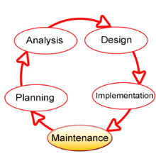

Figure 3.1 System Life Cycle

**3.1 Project Planning**

A system development methodology refers to framework that is used to structure, plan and contend the process of developing a system. It consists of the phases and actions taken to make the system come to light; this plan represents Agile system developments. Agile system development is an iterative software development which refers to a group of software development methodologies based on iterative development, where requirements and solutions evolve through collaboration between self-organizing cross-functional teams. Agile methods or agile processes generally promote a disciplined project management process that encourages frequent inspection and adaptation, leadership philosophy that encourages teamwork, self-organizing and accountability, a set of engineering best practices intended to allow for rapid delivery of high-quality software. figure 3.2 represent the agile model that is composed on different phases. In this model phases are executed sequentially and in backtracking mode that means the system all the time performs a testing of the previous phases. [6].

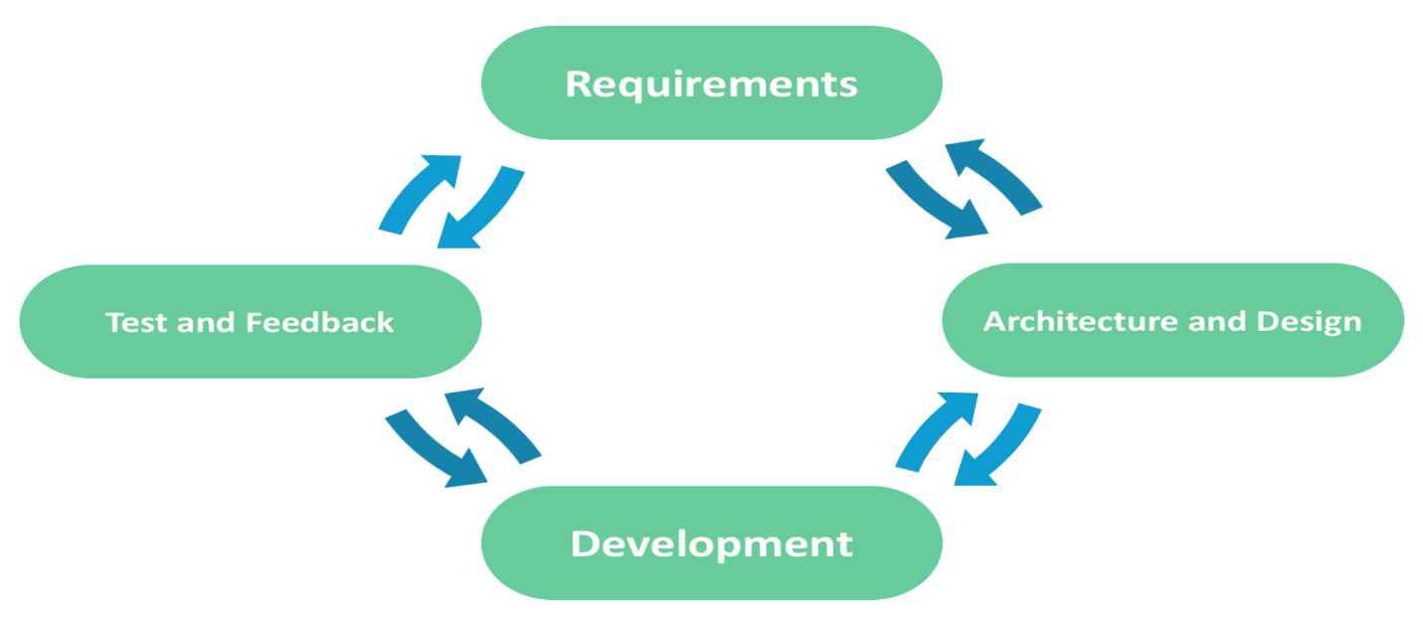

Figure 3.2 Agile Model [6]

**Requirements phases**

This is the initial phase of the development process where in the development team works closely with the customer to determine the customer's requirements for the product. The requirements phase identifies the functionality, performance levels, and other characteristics which the product must satisfy in order for it to be acceptable to the customer. The requirements developed in this phase serve as a foundation for the remaining phases of the development process, and as the customer acceptance criteria.

**3.1.1 Feasibility Study**

Is the total of the actions can be taken and the questions can be asked to determine whether an idea, thought or plan is likely to succeed, an effective study can guide whether to move forward with your idea, refine it, or to stop it.

this System is an important system that is needed in every Gym these days because it increases and manage communication between coach and the members under him and it give you some new ideas. This system is focusing on coaches who has a problem in communication and management of trainings with trainee and save time for the user by provide direct connection and support language Arabic.

**3.1.2 Gantt Chart**

About Gantt chart show a Figure 3.3 Planning and Analysis, Figure 3.4 Design and Figure 3.5 Implementation and Testing.

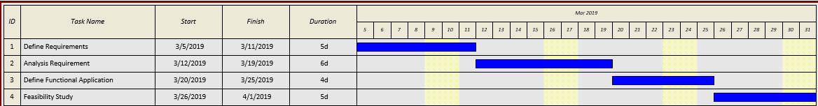

Figure 3.3 Planning and Analysis

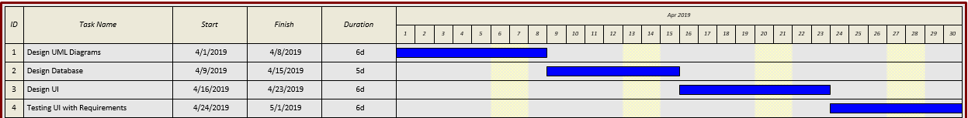

Figure 3.4 Design

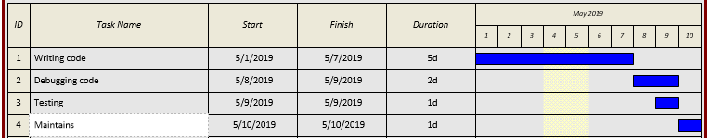

Figure 3.5 Implementation and Testing

**3.2 Analysis of the System**

The analysis phase defines the requirements of the system, independent of how these requirements will be accomplished.

**3.2.1 User Requirements**

**3.2.1.1 Functional Requirements:**

Means how the system behaves from user point of view. Consider that our system is information system, so it performs several functional requirements: -

* Sign up by using Firbase.
* Choose the coach.
* Confirm that the exercise is finished from Trainee side.
* Show the assigned exercises.
* Approve the trainee request from coach side.
* Add exercise to trainee from coach side.
* Rate the trainee.
* Show the trainee under the coach.

**3.2.1.2 Non-Functional Requirements:**

Non-functional requirements place constraints on how the system will do so. The nonfunctional requirement elaborates a performance characteristic of the system.

**Availability**

The system should be available, or uptime, means that the should be operational and available to use. This is specified because some systems are designed with expected downtime for activities.

### **Performance**

Performance requirements concern the speed of operation of a system. All the processes require fractions of second.

### **Usability**

Usability is the ease with which a user can learn to operate, prepare inputs for, and interpret outputs of system or component.

### **Reliability**

Reliability is the ability of a system to perform its required functions under stated conditions for a specific period of time.

### **Efficiency**

The system should utilize the resources: memory, processor speed, etc., and use them in effectively and efficient ways.

### **Modifiability**

Requirements about the effort required to make changes in the software. Often, the measurement is personnel effort(person-months).

### **System Requirements**

### About hardware requirements show table 3.1.

**Table 3.1 Hardware Requirements**

|  |  |
| --- | --- |
| **Specifications** | **Recommended Requirements** |
| Processor | 1.0 GHz or higher |
| Internal storage | 1 Gigabyte or higher |
| Memory | 512 MB or higher |
| Monitor | Touch screen 4 inches or higher |

### About software requirements show table 3.2.

**Table 3.2 Software Requirements**

|  |  |
| --- | --- |
| **Specifications** | **Recommended Requirements** |
| Operating System | Android |
| Front –end | Xml |
| Backend | JAVA |
| Application Store | PlayStore |
| Server | Firebase |
| Integrated Development Environment  (IDE) | Android Studio 3.3.2 |

### **Domain Requirements**

Domain requirements are important because they often reflect fundamentals of the application domain. If these requirements are not satisfied, it may be impossible to make the system work satisfactorily.

* This mobile application shall be designed to meet need coaches with high database protection.
* This mobile application requires service Firebase from google for build database and make it cloud.
* The processing speed shall be fast and must be measured in unit of time eq. update locations every time.

## NoSQL

One of the most fundamental choices to make when developing an application is whether to use a SQL or NoSQL database to store the data. Conventional SQL (i.e. relational) databases are the product of decades of technology evolution, good practice, and real-world stress testing. They are designed for reliable transactions and ad hoc queries, the staples of line of business applications. But they also come burdened with restrictions—such as rigid schema—that make them less suitable for other kinds of apps. NoSQL databases arose in response to those limitations. NoSQL systems store and manage data in ways that allow for high operational speed and great flexibility on the part of the developers. Many were developed by companies like Google, Amazon, Yahoo, and Facebook that sought better ways to store content or process data for massive websites. Unlike SQL databases, many NoSQL databases can be scaled horizontally across hundreds or thousands of servers. NoSQL databases can store non- relational data on a super large scale and can solve problems regular databases can't handle: indexing the entire Internet, predicting subscriber behavior, or targeting ads on a platform as large as Facebook. over 150 NoSQL database types exist now. [7]

## Firebase

Firebase is a mobile and web app development platform that provides developers with a plethora of tools and services to help them develop high-quality apps, grow their user base, and earn more profit. A Brief History, In April 2012, Firebase was created as a separate company that provided Backend-as-a-Service with real-time functionality. After it was acquired by Google in 2014, Firebase rapidly evolved into the multifunctional behemoth of a mobile and web platform that it is today. [8]

## Firebase Services

Firebase Services can be divided into three groups and can show in figure 3.6 service of Firebase: -

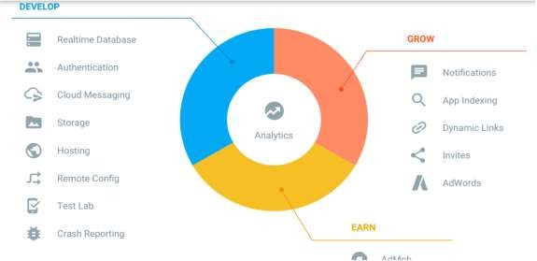

Figure 3.6 firebase services

this simple explanation for each service, [Cloud Functions is](https://firebase.google.com/products/functions/) run mobile backend code without managing servers, [Authentication](https://firebase.google.com/products/auth/) is Authenticate users simply by firebase, Gmail or facebok etc. securely, [hosting](https://firebase.google.com/products/hosting) is deliver web app assets with speed and security, [Cloud](https://firebase.google.com/products/storage/) [Storage](https://firebase.google.com/products/storage/) is store and serve files at Google scale, [Realtime Database](https://firebase.google.com/products/database) is store and sync app data in milliseconds, [Google Analytics](https://firebase.google.com/products/analytics/) is get free and unlimited app analytics, [Cloud](https://firebase.google.com/products/cloud-messaging/) [Messaging](https://firebase.google.com/products/cloud-messaging/) is send targeted messages and notifications, [Remote Config](https://firebase.google.com/products/remote-config/) is modify your app without deploying a new version, [Dynamic Links](https://firebase.google.com/products/dynamic-links/) is drive growth by using deep links with attribution, [App Indexing](https://firebase.google.com/products/app-indexing/) is drive search traffic to your mobile app, [Test Lab](https://firebase.google.com/products/test-lab/) is test your app on devices hosted by Google. [8].

# CHAPTER FOUR

**SOFTWARE DESIGN AND IMPLEMENTATION**

In system design phases, we will describe the system requirements, operating environment, system and subsystem architecture (Use Case Model, Sequence Diagram, Activity Diagram, GUI Screens).

## 4.1 Use Case Diagram

A Use Case Model describes the proposed functionality of a new system. A Use Case represents a discrete unit of interaction between a user and the system. Each Use Case describes the functionality to be built in the proposed system, which can include another Use Case's functionality or extend another Use Case with its own behavior. From figure

* 1. it is clear that the App is directed toward user to inform and help him/her.

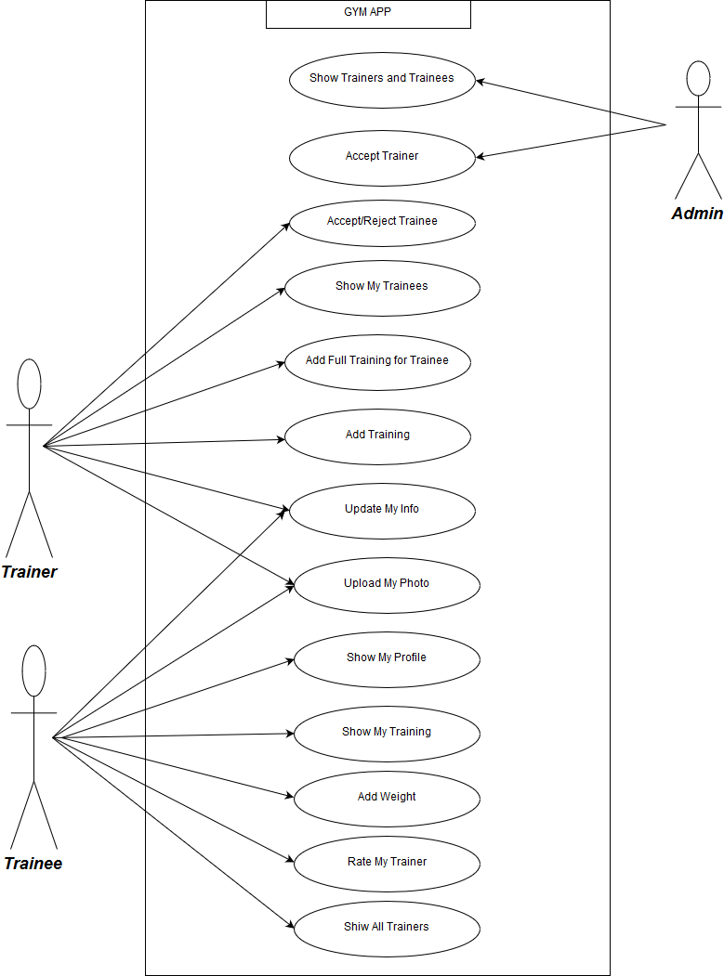

Figure 4.1 Use case diagram

## Class Diagram

The class diagram describes the attributes and operations of a class and also the constraints imposed on the system. The class diagrams are widely used in the modeling of object- oriented systems because they are the only UML diagrams which can be mapped directly with object-oriented languages.

The class diagram shows a collection of classes, interfaces, associations, collaborations and constraints. It is also known as a structural diagram. In Figure 4.2 can show class diagram.

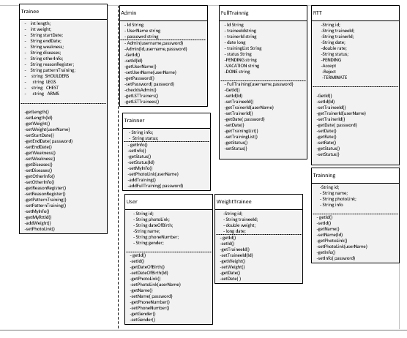

Figure 4.2 class diagram

## Activity Diagram

Activity diagram describes the flow of control in a system. It consists of activities and links. The flow can be sequential, concurrent, or branched.

Activities are nothing but the functions of a system. Numbers of activity diagrams are prepared to capture the entire flow in a system Activity diagrams are used to visualize the flow of controls in a system. This is prepared to have an idea of how the system will work when executed. In Figure 4.3 can show Activity diagram.

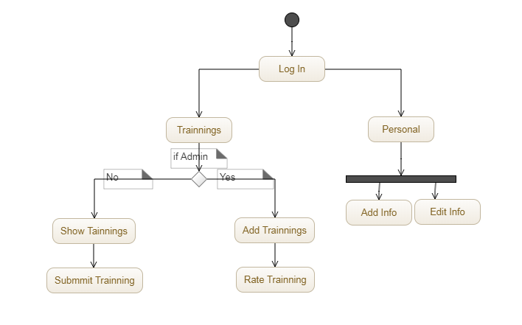

Figure 4.3 Activity diagram

## Sequence Diagram

A sequence diagram is an interaction diagram. From the name, it is clear that the diagram deals with some sequences, which are the sequence of messages flowing from one objector another.

Interaction among the components of a system is very important from implementation and execution perspective. Sequence diagram is used to visualize the sequence of calls in system to perform a specific functionality.

can be defined as the snapshot of the running system at a particular moment. In Figure 4.4 can show Sequence diagram for execute add training.

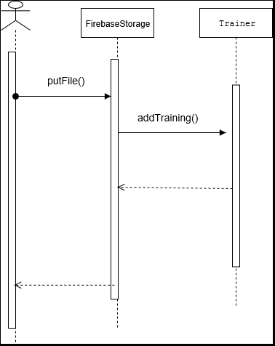

Figure 4.4 Sequence diagram

## Snapshot Firebase

In this part you can show snapshot from Firebase in figure 4.5 can show how store database by key – Value, in figure 4.6 storage images on firebase and figure 4.7 for authentication and sign by Gmail.

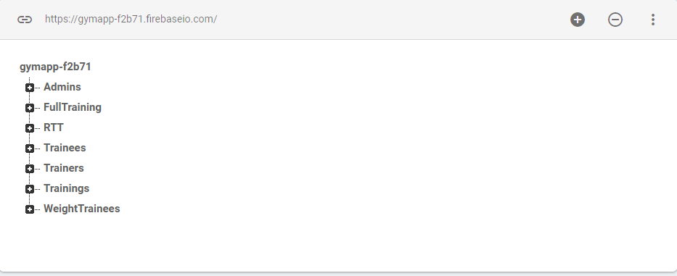

* 1. Database Key-Value

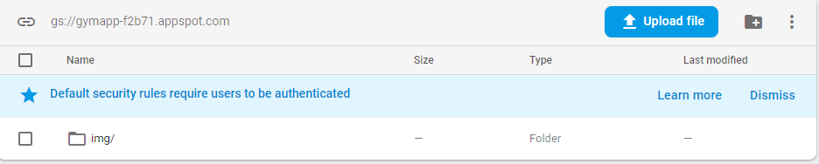

* 1. Storage images

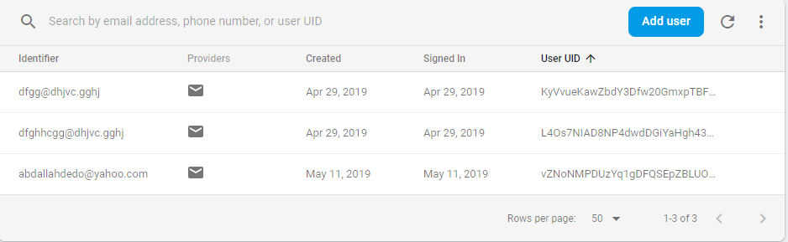

4.6 Authentication

## Implementation

In the software implementation phase, we will show how the system, user, and domain requirements have been implemented to produce completed system. Implementation refers to the final process of moving the solution from development status to production status. On receiving system design documents, the work is divided in modules/units and actual coding is started. Since, in this phase the code is produced so it is the main focus for the developer. This is the longest phase of the software development life cycle.

Here we will show the implementation phase by showing the final screens of the project and describing in details the functionalities that will be performed by the system through these screens.

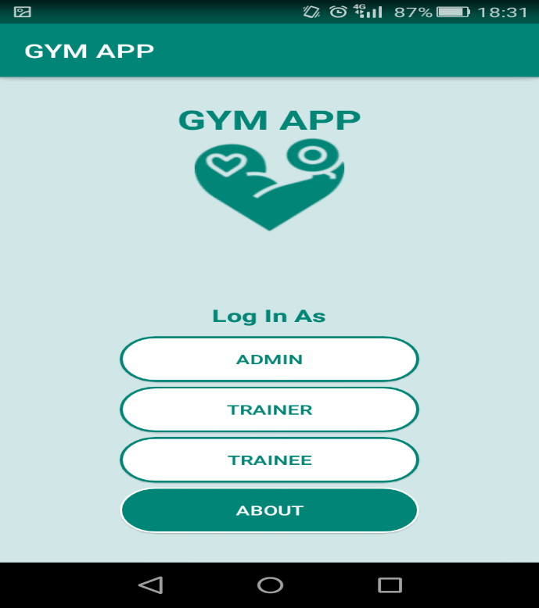

Figure 4.8 Login

The user can make log in as Admin, Trainer or Trainee from this screen, show that in figure 4.8.

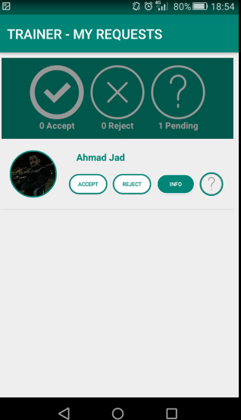

Figure 4.9 My Requests

Trainer can accept or reject the trainee from this screen, show that in figure 4.9.

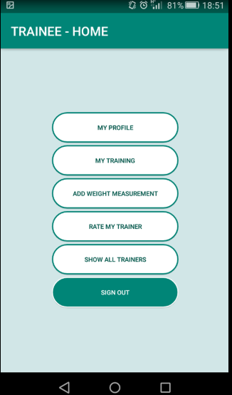

Figure 4.10 Home

Show activities of the Home in figure 4.10

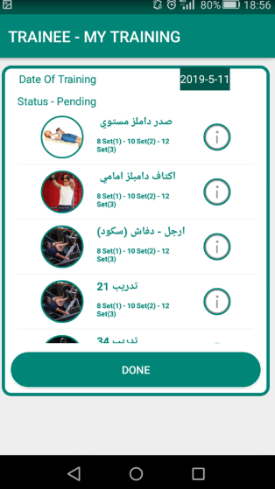

Figure 4.11 My Training

The user can show his trainings from this page, show that in figure 4.11.

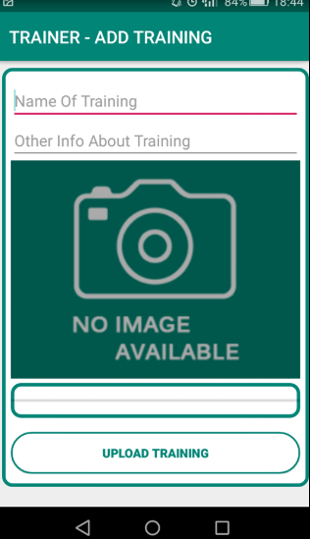

Figure 4.12 Add Training

The Trainer can add trainings from this page, show that in figure 4.12.

# CHAPTER FIVE RESULTS AND DISCUSSION

**5.1 Result**

**5.1.1 Expected Result**

In this project, we were interested in developing an App for people in Gym Life to help members of Gym in increase communication media between them and Trainers. The main idea, were to create App that is easy to use and efficient at the same time and can be accessed any time without constrains on the time and location. constraint on space storage, pay for increase space and get professional services. It is expected to allow App ready to provide several services, Authentication mobile number, create account for user, choose specific trainer, Add Training etc.

5.1.2 **Actual Results**

Now have terminated the work in semester, and the actual result is the same expected result.

# CHAPTER SIX

# CONCLUSION AND FUTURE WORKS

## Conclusion

In this App, have created Gym that will help to increase communication between activities in a special and distinctive in an easy, fast and sufficient.

Now have terminated the work in semester project graduation, we can have said that we have realized our objectives where main pillars were completed and developed an app that helps Gym Trainers in increase communication media between them and trainee.

Our goal were creativity and usability, also can be used by a large part of the Gym’s and learn huge experience in Android developer, NoSQL Database Firebase.

### **Future Work**

In the near future, complete all requirements and add functionalities will be added to this system, these functions will be like:

* + 1. Improved application design.
    2. Authentication mobile number.
    3. Show list likers of training.
    4. Add payment method.

# References

[1] page 1 Wei-MengLee." beginning Android Application Development " .19 April 2011. Wrox; 1 edition. **ISBN-10:** 9781118017111.

[2] AndroidTutorial.[Online].Available <https://www.tutorialspoint.com/android/android_application_components.htm>.

[3] <https://www.thetrainingnotebook.com/>

[4] Coach Pro <https://itunes.apple.com/us/app/coach-pro/id484985911?mt=8>

[5] FitSW <https://www.fitsw.com/>

[6] <http://www.myglobalit.com/blog/waterfall-vs-agile-models-software-development>

[7] <https://www.infoworld.com/article/3240644/nosql/what-is-nosql-nosql-databases->[explained.html](https://www.infoworld.com/article/3240644/nosql/what-is-nosql-nosql-databases-explained.html)

[8] <https://hackernoon.com/introduction-to-firebase-218a23186cd7>

[9] <https://www.wikihow.com/Have-a-Good-General-Healthy-Body>

[10] <https://en.wikipedia.org/wiki/Health_club>

[11] https://en.wikipedia.org/wiki/Health